|  |
| --- |
| EPAM Systems, RD Dep. |
| MTN.BI.08 Dimension Table Techniques |

|  |  |  |  |  |  |
| --- | --- | --- | --- | --- | --- |
| REVISION HISTORY | | | | | |
| Ver. | Description of Change | Author | Date | Approved | |
| Name | Effective Date |
| 1.0 | Initial status | Hanna Hul | 22-NOV-2017 |  |  |

Contents

1. Create Geo Hierarchy 3

2. Dimension Hierarchy Analysis 3

# Geo Hierarchy

select*from geo;  
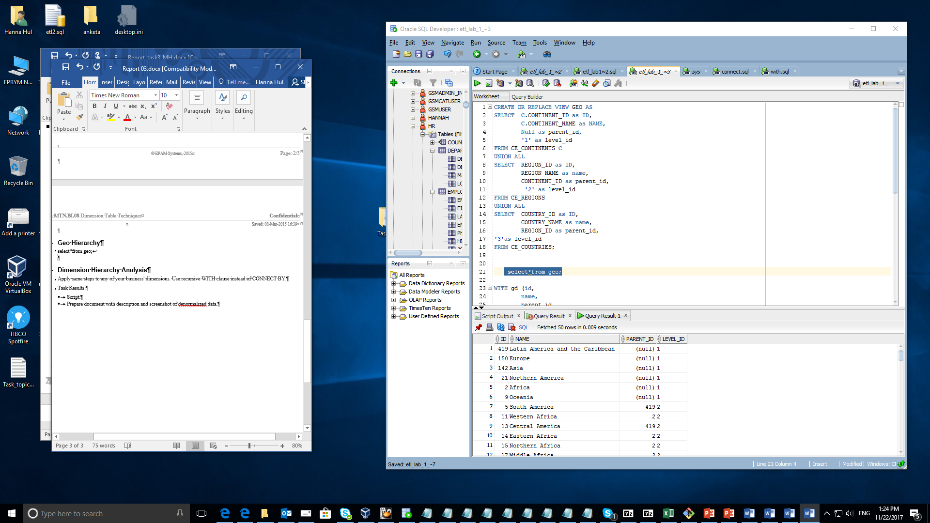

Query using connect by

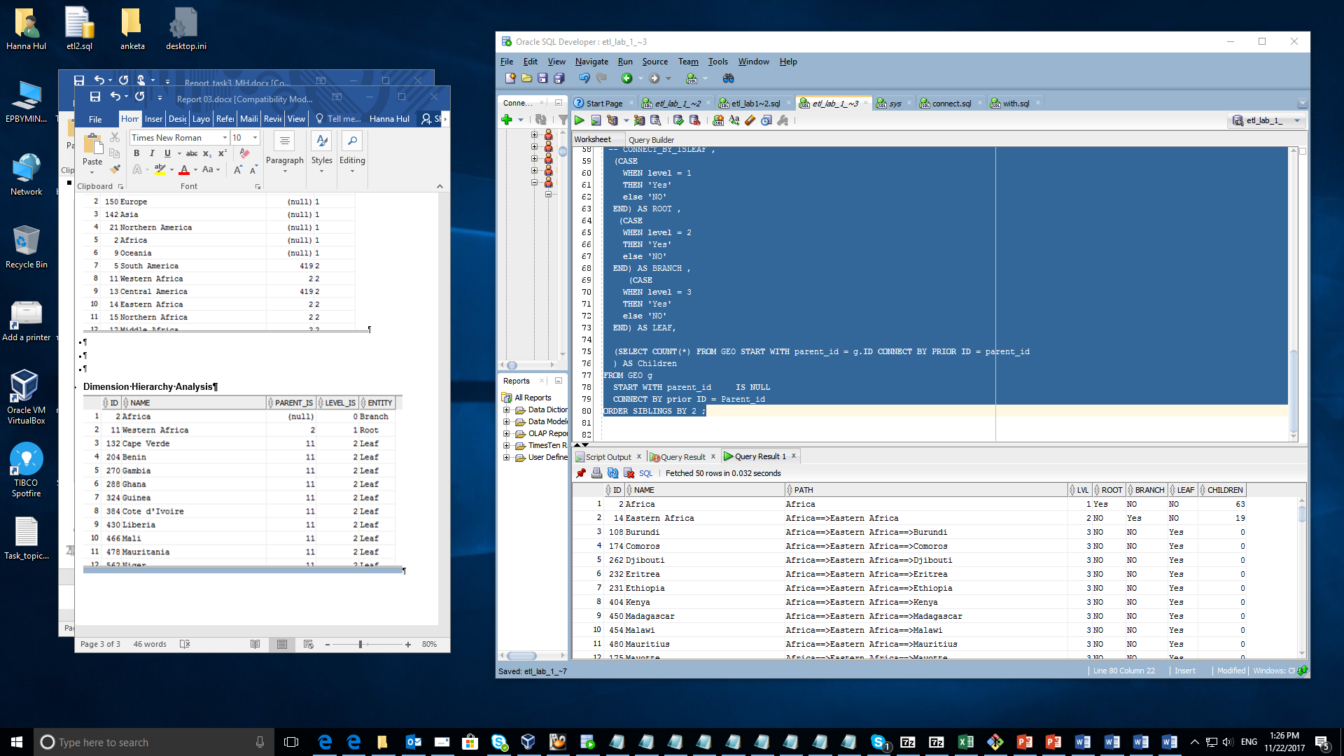

# Dimension Hierarchy Analysis

